CLINICAL INVESTIGATION
What Do Patients With Glaucoma See? Visual Symptoms
Reported by Patients With Glaucoma
Cindy X. Hu, MD, Camila Zangalli, MD, Michael Hsieh, Lalita Gupta, Alice L. Williams, MD,
Jesse Richman, MD and George L. Spaeth, MD

Abstract: Background: Vision loss from glaucoma has traditionally been described as loss of “peripheral vision.” In this prospective study, we aimed to improve our clinical understanding of the visual symptoms caused by glaucoma by asking patients specific detailed questions about how they see. Methods: Patients who were clinically diagnosed with various types and stages of glaucoma were included. All had a comprehensive ocular examination, including Octopus visual field testing. Patients were excluded if they had other ocular conditions that affected their vision, including cornea, lens or retina pathologies. Patients responded to an oral questionnaire about their visual symptoms. We investigated the visual symptoms described by patients with glaucoma and correlated the severity of visual field loss with visual symptoms reported. Results: Ninety-nine patients completed the questionnaire. Most patients (76%) were diagnosed with primary open-angle glaucoma. The most common symptoms reported by all patients, including patients with early or moderate glaucoma, were needing more light and blurry vision. Patients with a greater amount of field loss (Octopus mean defect .+9.4 dB) were more likely to report difficulty seeing objects to one or both sides, as if looking through dirty glasses and trouble differentiating boundaries and colors. Conclusions: Vision loss in patients with glaucoma is not as simple as the traditional view of loss of peripheral vision. Needing more light and blurry vision were the most common symptoms reported by patients with glaucoma.
Key Indexing Terms: Glaucoma; Visual symptoms; Peripheral vision;
Visual field; Contrast sensitivity. [Am J Med Sci 2014;348(5):403–409.]

METHODS

Study Participants
All patients in this study were established patients at the Glaucoma Service of Wills Eye Hospital. Incoming patients returning for an office visit between July 2011 and December 2011 were screened before their office visit to determine their eligibility for study inclusion. During this time period, all eligible patients were approached (n 5 102) and 3 patients refused to participate. Written informed consent was obtained from all study participants (n 5 99). The Research Ethics Board of Wills Eye Hospital approved this study following the principles of the Declaration of Helsinki.
Inclusion criteria required patients to be clinically diagnosed with glaucoma at a previous visit at least 1 year before. Patients with primary open-angle glaucoma, normaltension glaucoma, pseudoexfoliative glaucoma and pigmentary glaucoma were included in the study. A diagnosis of glaucoma was based on characteristic optic nerve damage on slit-lamp examination (defined as definite notch in the neuroretinal rim or absence of neuroretinal rim not due to another known cause) with corresponding VF defects.¹⁸
The American Journal of the Medical Sciences Volume 348, Number 5, November 2014
Patients were excluded if they had other ocular conditions, trauma or surgeries that affected their vision, such as
FIGURE 1. (A) Patient view with normal vision. (B) Patient view with glaucoma.⁸ Loss of vision in glaucoma has been traditionally described as “tunnel vision” or as if “looking through a straw” (courtesy: National Eye Institute and National Institutes of Health).
cornea, lens or retina pathologies. Patients with previous glaucoma or cataract surgeries were included. However, patients who had surgeries within the past year as well as previous cornea or retina surgeries were excluded. Other exclusion criteria included patients with extreme refractive errors such as high myopia (26.0 or higher), high hyperopia (+6.0 or higher) or astigmatism, acute angle-closure glaucoma, ocular hypertension, history of stroke, neurologic pathology or insufficient understanding of English that would prevent the patient from participating in the study. Cataracts and intraocular lens opacity were graded based on clinical judgment of nuclear sclerosis severity. To reduce the effects of cataracts or intraocular lenses on vision, patients were excluded if they had . +1 nuclear sclerosis, . +1 posterior capsule opacification or multifocal intraocular lenses in either eye.

Questionnaire
A questionnaire was developed based on the most frequent visual symptoms mentioned by patients in previous studies on visual disability in glaucoma^{17,19,20} as well as the clinical experience of a glaucoma specialist (G.L.S.). An initial version of the questionnaire was administered to 8 patients (not included in this study). After interviewer debriefings, modifications to question wording was made for 2 questions to reduce confusion for pa-
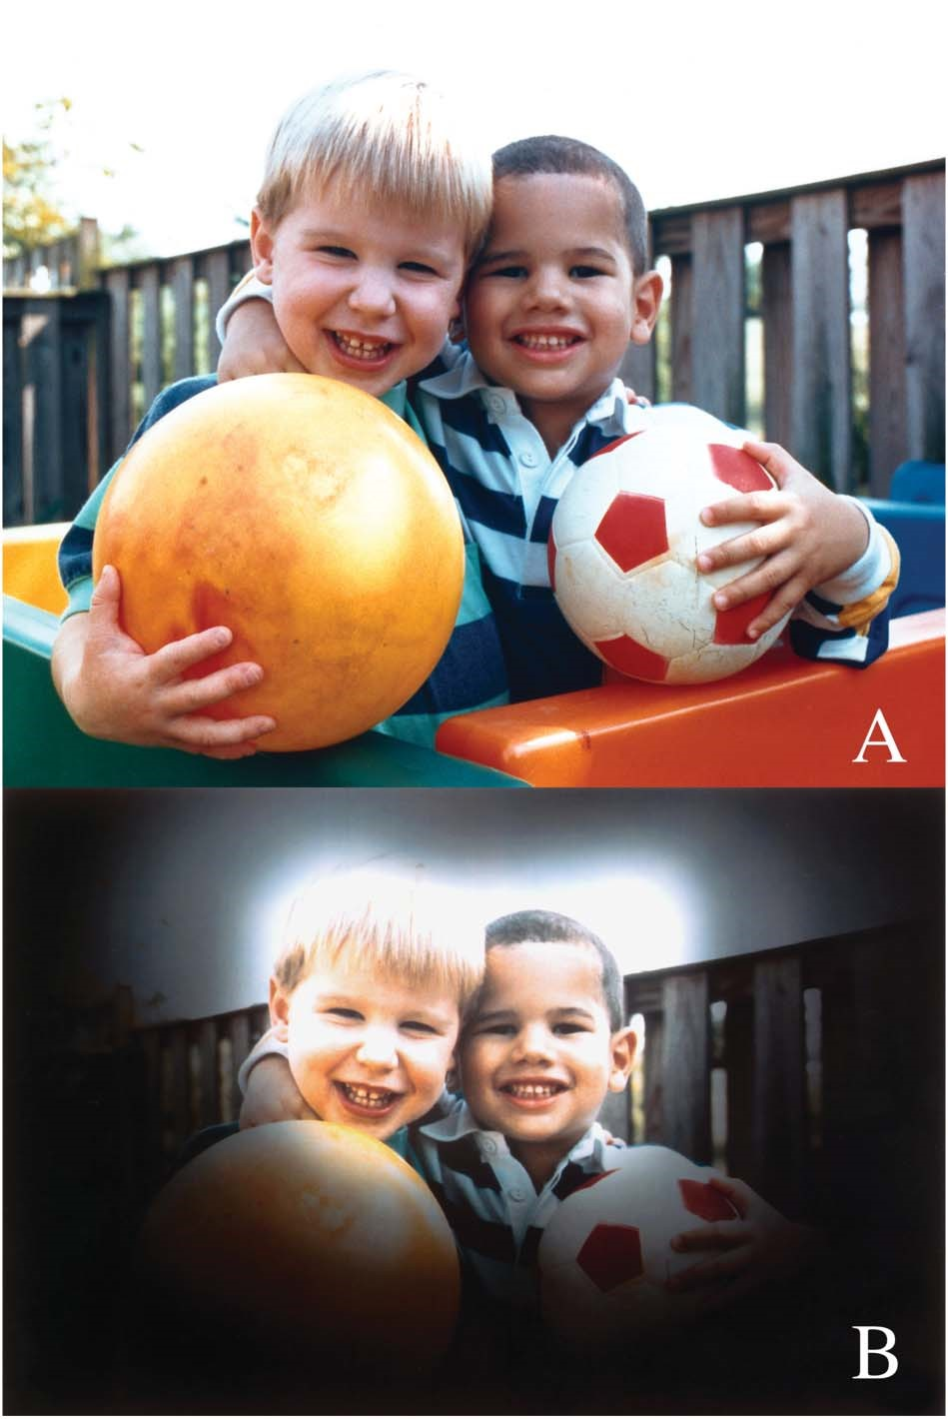
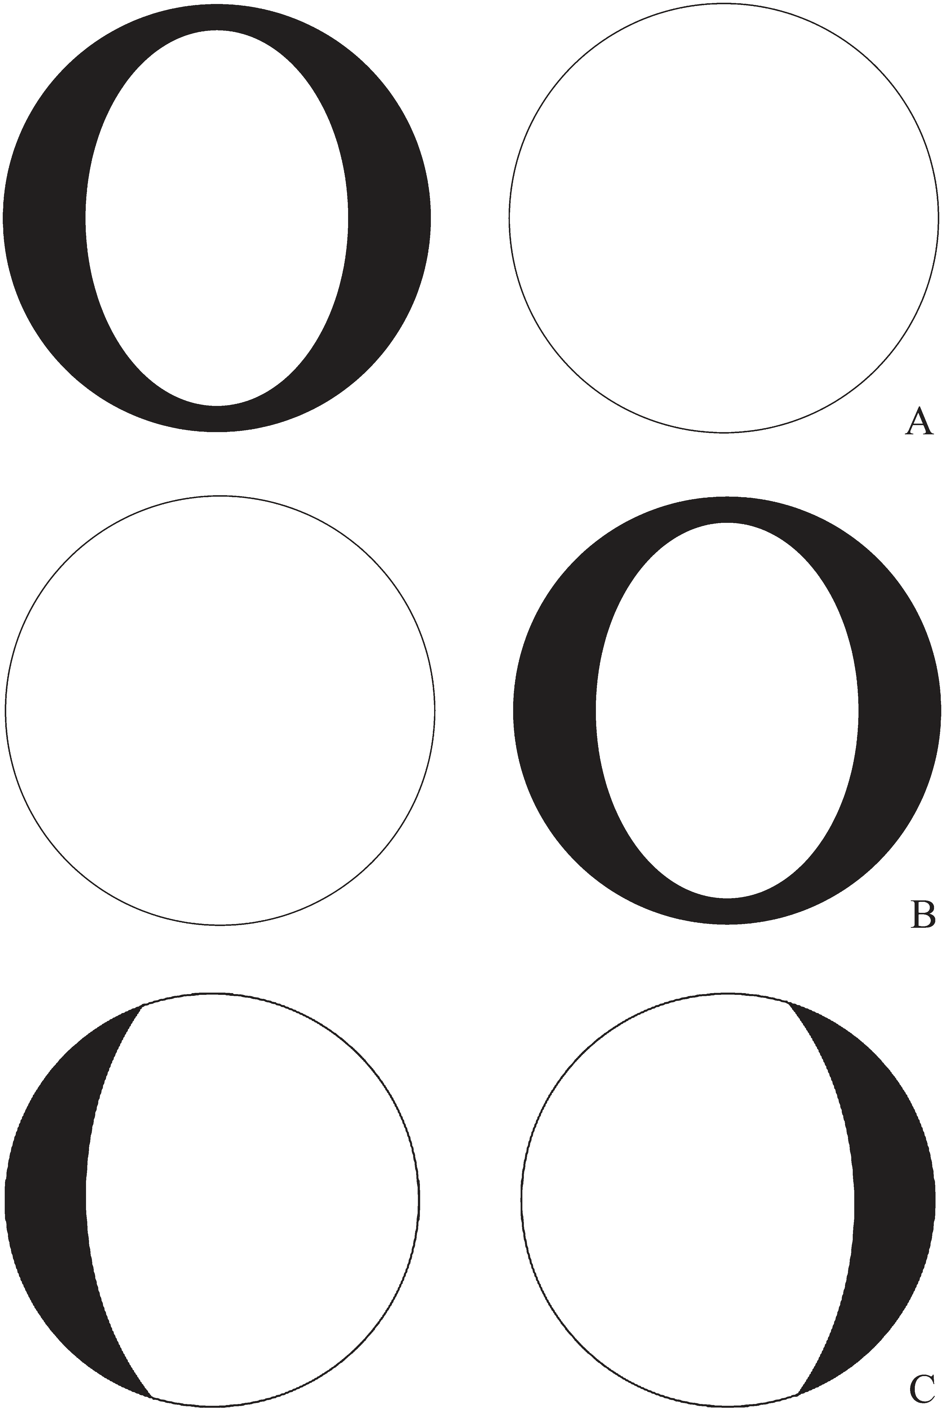
FIGURE 2. (A) Loss of “peripheral vision” can use an eye or a person as its central reference point. Loss of peripheral vision for the left eye means loss of vision toward the edges of the VF of that eye. (B) The same is true for the right eye. (C) Loss of peripheral vision for the person implies loss of sight off to the person’s sides, either the right and left side (as shown) or above and below. VF, visual field.
tients. The final version of the questionnaire consisted of 25 “yes or no” as well as 3 open-ended questions (Appendix).
A research technician administered the questionnaire orally to all study participants. A second research technician administered the same questionnaire for a second time, a minimum of 15 minutes later, to test for agreement. The interviewers read the questions out loud as they stand in the written form of the questionnaire. Patients were asked to report on the presence of their visual symptoms after correction for their refractive error and astigmatism. Patients were asked to use their current spectacles or contact lenses at the time the questionnaire was given. Trial lenses were available for patients if they did not have an updated refraction.

Visual Assessment
After the questionnaire was completed, all patients had a comprehensive ocular examination, including slit-lamp examination and fundoscopy. VFs were tested monocularly for both eyes using Octopus 900 Static Perimetry 24-2 SITA standard (Haag-Streit, Mason, OH). The best-corrected visual acuity (BCVA) was measured using Snellen’s chart at 20 feet.
TABLE 1. Characteristics of 99 questionnaire respondents
Characteristic |  | No. of  participants
Age | Mean (SD) 5 70 (13.5) | 99
Gender | Female | 54
 | Male | 45
Race | White | 66
 | African American | 29
 | Other | 4
MD category | Early (MD, 20.7 to +4.4 dB) | 47
 | Moderate (MD, +4.5 to +9.4 dB) | 26
 | Advanced (MD, +9.5 to +15.3 dB) | 14
 | Severe (MD, +15.4 to +23.1 dB) | 7
 | End stage (MD, .23.2 dB) | 5
Type of glaucoma | Primary open-angle glaucoma  Chronic angle-closure glaucoma | 75  14
 | Pseudoexfoliative glaucoma | 6
 | Pigmentary glaucoma | 4
Lens status | No nuclear sclerosis or other apparent lens change | 46
 | Trace nuclear sclerosis | 13
 | +1 Nuclear sclerosis | 33
 | +1 Posterior capsular opacity | 7
MD, mean defect.

Statistical Analysis
The study concluded at the end of December 2011, at which point, 99 patients had been interviewed. All 99 patients were stratified by the severity of glaucomatous damage into 1 of 5 categories using the Octopus mean defect (MD) score of their better eye: 20.7 to +4.4 dB (early glaucoma), +4.5 to +9.4 dB (moderate glaucoma), +9.5 to +15.3 dB (advanced glaucoma), +15.4 to +23.1 dB (severe glaucoma) and .23.2 dB (end-stage glaucoma). This staging system was derived from a panel of glaucoma specialists who used published literature to convert the Humphrey’s threshold values to Octopus values.^{18,21,22} We looked at differences between age, gender and race between the 5 MD categories with analysis of variance and Pearson’s x² tests. The association between MD category and questionnaire responses was assessed using the Cochran-Armitage trend test. The Cochran-Armitage trend test assesses for the presence of an association between a variable with 2 categories (patient response) and a variable with multiple categories (MD categories). We used Fisher’s exact test to assess symptoms by MD # +9.4 and MD . +9.4 dB. The association between location of VF defect and visual symptoms reported was also determined using Fisher’s exact test. Data was analyzed using SAS Analytics Pro statistics software, version 9.2 (SAS Institute, Inc, Cary, NC).
We transcribed the responses from the open-ended questions looking for any descriptor of visual symptoms. Words such as blurry, blurred and blurriness were all considered to be derived from 1 descriptor, blur. When descriptors such as foggy, blurry and hazy were used, they were considered different descriptors. The frequency of descriptors was tallied.
The location of all VF defects was documented by better eye and worse eye. In addition, we compared the agreement of laterality of field loss and the laterality of symptoms reported. When the person reported difficulty seeing to the left with corresponding left-sided field loss, the person was listed as “field and symptoms” agree. When the person reported difficulty seeing to the left and the VF loss was right sided, the person was listed as “field and symptoms” disagree and vice versa. If the person did not report difficulty seeing to one or both sides and did not have lateral field defects, then the person was listed as “field and symptoms” agree.

RESULTS
A summary of patient characteristics is displayed in Table 1. The average number of years diagnosed with glaucoma was 8.4 years. For each MD group, the average number of years diagnosed with glaucoma was 7.7 years for early, 7.6 years for moderate, 8.9 years for advanced, 8.5 years for severe and 17.2 years for end stage. There were no age or gender differences between the 5 MD groups, but race significantly varied (Table 2). Most patients (75%) had a BCVA of 20/20 in their better eye, and 91% of patients had a BCVA of 20/30 or better.
When considering all patients, 92% reported at least 1 visual symptom after correction for their refractive error and astigmatism. Table 3 displays the most common symptoms reported by all patients. For patients with early or moderate glaucoma without cataract (n 5 33), the most common symptoms reported were needing more light (58%), blurry vision (52%) and seeing glare (52%).
For the 8 patients (8%) who did not report any visual symptoms, the average MD of the better eye was 4.5 dB (range, 0.9–7.9 dB). From the VFs of the better eye, 4 patients had mild generalized field depression, 3 had an arcuate scotoma and 1 had a paracentral scotoma. All patients had early or moderate glaucoma by MD category and a BCVA #20/40.
Patients were asked the open-ended question: “How is your vision different?” from either 5 or 15 years ago. The most common response was “blurriness” (15%). Although we received similar comments from other patients, 1 patient expressed, “The world seems more blurry. It’s just not real clear. Things used to be crisper”. Another patient described, “It’s like looking underwater.” Other common responses to describe the change in vision were “fuzzy” (6%), “less clear” (6%), “harder

TABLE 2. Age, gender and race by MD category
MD category
 | Early | Moderate | Advanced | Severe | End stage | P
Age | 67 (SD: 13) | 76 (SD: 13) | 68 (SD: 10) | 78 (SD: 14) | 81 (SD: 13) | 0.13
Gender (female:male) | 23:24 | 15:11 | 8:6 | 4:3 | 4:1 | 0.21
Race (white:other) | 37:10 | 14:12 | 9:5 | 6:1 | 1:4 | 0.02ª
a
P , 0.05.
MD, mean defect.

TABLE 3. Most common visual symptoms reported by
all patients
Symptom | % Reported
Needing more light | 57
Blurry vision | 55
Seeing glare | 46
Difficulty seeing objects off to both sides | 36
Letters appearing faded when reading | 30
Difficulty seeing objects off to left side | 27
Seeing too much light | 26
Area(s) darker or missing | 26
Seeing as if looking through dirty glasses | 25
Difficulty seeing objects off to right side | 24
Seeing as if looking through clouds | 23
to read” (5%), “hazy” (4%) and “cloudy” (2%). No patient complained of “tunnel vision” or loss of side vision. No patient provided novel information from the open-ended questions that were not addressed in the questionnaire.
Patients in a higher MD category were more likely to report 6 visual symptoms, shown in Table 4. Compared with patients with early or moderate glaucoma, those with field loss worse than MD of +9.4 dB were significantly more likely to report these 6 symptoms (P# 0.05).
Of the 198 eyes in the study, 196 were diagnosed with glaucoma. Two participants had unilateral glaucoma. Of the 196 eyes, there was agreement between laterality of field loss and laterality of symptoms 68% of the time, and no agreement 20% of the time. For 24 eyes (12%), it was not possible to determine whether there was agreement between laterality of field loss and laterality of symptoms reported.
Table 5 provides a detailed account of the location of VF defects by better eye and worse eye. There was no significant association between location of VF and symptoms reported for the 3 most common symptoms (P5 0.89).
Patients were administered the same questionnaire twice, a minimum of 15 minutes apart. The average percent agreement was 0.89 (range, 0.73–1) between the 2 responses, and the average Kappa for agreement was 0.60.

DISCUSSION
The purpose of this study was to determine how glaucoma affects vision from patients’ point of view. We administered a questionnaire to patients with glaucoma to determine visual symptoms reported, and we correlated the severity of VF loss with symptoms reported.
In contrast to the traditional view of glaucoma,^{4–7} loss of peripheral vision was not the most common symptom reported. Needing more light and blurry vision were the most common symptoms reported, and these symptoms were not associated with any specific area of VF defect. These symptoms may be more consistent with loss of contrast sensitivity than field loss. Decreased contrast sensitivity is an established finding in patients with glaucoma, which may be contributing to reduced image quality.^{11,23–25} The pathological thinning of the nerve fiber layer that occurs in glaucoma may explain why blurry vision was one of the most commonly reported symptoms.^{26,27}
Other symptoms reported by more than 25% of patients in our study included seeing glare, letters appearing faded when reading, seeing too much light or seeing as if looking through dirty glasses. These reported symptoms suggest that decreased image quality, not simply VF loss or “tunnel vision,” plays an important role in glaucoma. No patient in this study reported “tunnel vision.” Crabb et al²⁸ also found that “tunnel vision” does not accurately describe what patients with glaucoma perceive. They asked patients with primary open-angle glaucoma to select 1 image of 6 choices that most closely represented their perception of their VF loss, and the most frequently selected images were blurred patches and missing patches. No patient in their study selected the image with a distinct black tunnel or black patches.²⁸
TABLE 4. Association between MD category and visual symptoms reportedª
MD category (n)
Symptom Patient response Early Moderate Advanced Severe End stage P
Difficulty seeing objects to both sides | Yes | 12 | 8 | 7 | 5 | 4 | ,0.001
 | No | 35 | 18 | 7 | 2 | 1
Difficulty seeing objects to left side | Yes | 7 | 8 | 3 | 4 | 5 | ,0.001
 | No | 40 | 18 | 11 | 3 | 0
Difficulty seeing objects to right side | Yes | 4 | 7 | 6 | 3 | 4 | ,0.001
 | No | 43 | 19 | 8 | 4 | 1
Trouble differentiating colors | Yes | 5 | 4 | 3 | 2 | 4 | 0.001
 | No | 42 | 22 | 11 | 5 | 1
Trouble differentiating boundaries | Yes | 5 | 2 | 2 | 2 | 3 | 0.01
 | No | 42 | 24 | 12 | 5 | 2
As if looking through dirty glasses | Yes | 8 | 5 | 7 | 2 | 3 | 0.01
 | No | 39 | 21 | 7 | 5 | 2
ª ficant association (P , 0.05) are shown.
Only symptoms with a statistically signi

Along with a decrease in the quality of vision, our study found that the fourth, sixth and ninth most common complaints were related to difficulties seeing to 1 or both sides. There was an agreement between laterality of field loss and laterality of symptoms reported approximately 65% of the time, suggesting that field loss plays a role in difficulty seeing to the sides. However, most patients in our study did not have a constricted VF. There was no agreement between laterality of field loss and laterality of symptoms in 20% of eyes, suggesting that it may not be simply the VF accounting for symptoms reported. Deterioration of image quality or reduced contrast sensitivity
TABLE 5. Areas of VF defects by better eye and worse eye
Areas of VF defect | Better eye (n) | Worse eye  (n)
Normal | 18 | 3
Nonspecific pattern of depressed points | 17 | 13
Mild generalized field depression | 12 | 9
Nasal step | 11 | 10
Paracentral scotoma | 4 | 7
Superior arcuate defect | 18 | 11
Inferior arcuate defect | 2 | 5
Both arcuate defect and nasal step | 6 | 7
Both superior and inferior arcuate defect | 2 | 11
Constricted VF | 5 | 17
Severe generalized field depression | 2 | 6
Total | 97 | 99
at the “periphery” may also play a role in difficulty seeing to 1 or both sides, as shown in Figure 3. This is supported by Tochel et al²⁹ who reported that patients with glaucoma have abnormally high-contrast thresholds (ie, low-contrast sensitivity) without correlation to field loss. It was not possible to determine agreement between laterality of field loss and laterality of symptoms reported for 24 eyes in our study. These patients had a nonspecific pattern of field loss or paracentral scotoma that was neither predominately right sided or left sided.
With increasing amounts of field loss, the likelihood of having visual symptoms increased, as would be expected. For each of the 6 symptoms that showed an association with higher MD score, patients with field loss worse than MD +9.4 dB were more likely to report symptoms. This suggests that patients can have significant field loss before reporting visual symptoms. A previous study speculated that patients with glaucomatous field defects may experience cortical reorganization or a filling in phenomenon.³⁰ The defect may be concealed by the colors and patterns of the surroundings such that the brain composes a plausible image.³⁰ In the study by Crabb et al²⁸, 16% of patients selected the image with missing patches in their vision, which was designed to illustrate the filling in phenomenon. Similarly, our study found that 26% of patients reported areas darker or missing in their vision. These findings suggest that what patients actually see is more complex than VF alone, and that patients with glaucoma do not simply develop “tunnel vision.”
Most patients in our study had good visual acuity, but 92% of patients reported at least 1 visual symptom. Patients may have poor image quality even in those with good visual acuity.¹¹ All patients who did not report any visual symptoms had VF defects in their better eye, indicating the asymptomatic nature of early disease even in the presence of objective VF defects.
Teaching people that glaucoma causes loss of peripheral vision may teach them to ignore the early signs of glaucoma. We found that the most common symptoms reported by patients with early or moderate glaucoma were needing more light, blurry vision and seeing glare. Even mild or moderate glaucomatous vision loss is associated with significant visual disability and reduced ability to perform visually related tasks, such as reading or driving.^{17,31,32} Furthermore, there is reduced quality of life and increased depression rates among patients with increasingly severe glaucoma.^{33,34} Earlier detection of disease and implementation of treatment may help preserve visual function and improve quality of life. Providing insight about visual symptoms due to glaucoma may be helpful for clinicians, patients and researchers. We therefore recommend that these symptoms be emphasized to patients at risk for glaucoma in public awareness campaigns and in educational materials.
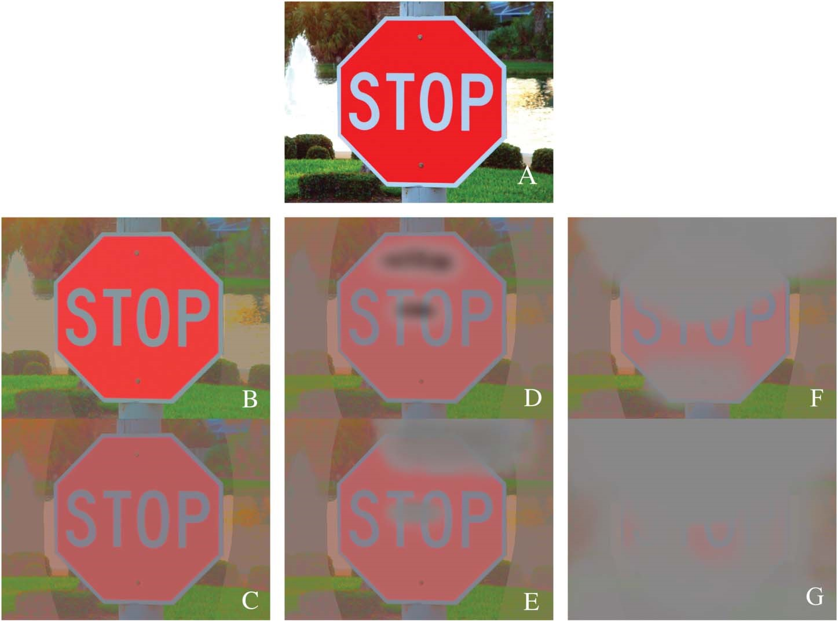
FIGURE 3. A graphic illustration of a possible progression of visual loss in a patient with glaucoma. (A) Normal vision, early glaucoma. (B) Early loss of contrast sensitivity. (C) Severe loss of contrast sensitivity. (D) Light paracentral and arcuate scotomas. (E) Dense scotomas. (F) Advanced bilateral disease. (G) Very advanced bilateral disease.
An important limitation of this study was the inability to determine the actual cause for the visual symptoms described. Since other known causes for decreased vision were excluded, most had excellent visual acuity, and none had a visually symptomatic cataract, the presumption is that the cause for the symptoms was glaucoma.
There are several other limitations. The nature of symptoms reported suggests that loss of contrast sensitivity plays role in glaucoma, but we cannot directly verify loss of contrast sensitivity in our patients because it was not measured. Symptoms reported may have been due to loss of contrast sensitivity, acuity or field, and their relative impacts are not clear. We did not test for near visual acuity, which may also have contributed to some of the symptoms reported, such as blurry vision.
Although we assessed visual symptoms by asking how patients see, we did not determine which eye was responsible for the symptoms reported. It has been shown that functional ability and quality of life is closely related to vision status in the better eye,^{35–37} so we analyzed patient responses using the better eye MD. Previous studies have found that monocular VFs overestimate vision loss compared with binocular integrated VFs.^{38,39} This is a limitation of our study, and our future studies will consider including both monocular and integrated VF assessments. Also, after stratification of our patients by MD category, race differed between the 5 groups, which may have confounded our results.
Despite these limitations, this is a novel study investigating visual symptoms reported by patients with glaucoma. We asked patients specific detailed questions about how they see to gain a better understanding of vision loss caused by glaucoma. Our study found that the most common symptoms reported by all patients, including those with early or moderate glaucoma, were needing more light and blurry vision. Vision loss in patients with glaucoma is not as simple as the traditional view of loss of peripheral vision or “tunnel vision.”
dsfdfd
The authors of the paper [1] discovered that the number of people with glaucoma are 200 million.

Bibliography

[1] | P. D. E. D. e. a. Resnikoff S, «Global data on visual impairment in the year 2002,» Bull World Health Organ, p. 82:844–51., 2006.
[2] | A. T. B. H A Quigley, «The number of people with glaucoma worldwide in 2010 and 2020,» British Journal of Ophthalmology, pp. 262-267, 2006.

REFERENCES
- Resnikoff S, Pascolini D, Etya’ale D, et al. Global data on visual impairment in the year 2002. Bull World Health Organ 2004;82:844–51.
- Pascolini D, Mariotti SP. Global estimates of visual impairment: 2010. Br J Ophthalmol 2011;96:614–8.
- Quigley HA, Broman AT. The number of people with glaucoma worldwide in 2010 and 2020. Br J Ophthalmol 2006;90:262–7.
- Duke-Elder S. Diseases of the Lens and Vitreous: Glaucoma and Hypotony, in System of Ophthalmology Volume XI. London, United Kingdom: Henry Kimpton; 1969.
- Chandler PA, Grant WM. Glaucoma, 2nd ed. Philadelphia (PA): Lea & Febiger; 1979.
- Kolker AE, Hetherington J Jr. Becker-Shaffer’s Diagnosis and Therapy of the Glaucomas, 4th ed. St Louis (MO): Mosby Co; 1976.
- Heilmann K, Richardson KT. Glaucoma: Conceptions of a Disease. Philadelphia (PA): WB Saunders Co; 1978.
- Facts About Glaucoma. National Eye Institute/National Health Institutes. 2012. Available at: http://www.nei.nih.gov/health/glaucoma/ glaucoma_facts.asp#3a. Accessed July 24, 2012.
- Pacheco-Cutillas M, Edgar DF, Sahraie A. Acquired color vision defects in glaucoma—their detection and clinical significance. Br J Ophthalmol 1999;83:1396–402.
- Drance SM, Lakowski R, Schulzer M, et al. Acquired color vision changes in glaucoma. Use of 100-hue test and Pickford anomaloscope as predictors of glaucomatous field change. Arch Ophthalmol 1981;99:829–31.
- Hawkins AS, Szlyk JP, Ardickas Z, et al. Comparison of contrast sensitivity, visual acuity, and Humphrey visual field testing in patients with glaucoma. J Glaucoma 2003;12:134–8.
- Lakowski R, Drance SM. Acquired dyschromatopsias: the earliest functional losses in glaucoma. Doc Ophthalmol Proc Ser 1979;19:159–65.
- Motolko M, Drance SM, Douglas GR. The early psychophysical disturbances in chronic open angle glaucoma: a study of visual functions with asymmetric disc cupping. Arch Ophthalmol 1982;100:1632–4.
- Ritch R, Shields MB, Krupin T. The Glaucomas, 2nd ed. St Louis (MO): Mosby Co; 1996.
- Pennebaker GE, Stewart WC. Temporal visual field in glaucoma: a re-evaluation in the automated perimetry era. Graefes Arch Clin Exp Ophthalmol 1992;230:111–4.
- Lee BL, Gutierrez P, Gordon M, et al. The Glaucoma Symptom Scale. A brief index of glaucoma-specific symptoms. Arch Ophthalmol 1998;116:861–6.
- Nelson P, Aspinall P, Papasouliotis O, et al. Quality of life in glaucoma and its relationship with visual function. J Glaucoma 2003;12: 139–50.
- Mills RP, Budenz DL, Lee PP, et al. Categorizing the stage of glaucoma from pre-diagnosis to end-stage diagnosis. Am J Ophthalmol 2006;141:24–30.
- Viswanathan AC, McNaught AI, Poinoosawmy D, et al. Severity and stability of glaucoma: patient perception compared with objective measurement. Arch Ophthalmol 1999;117:450–4.
- Nelson P, Aspinall P, O’Brien C. Patients’ perception of visual impairment in glaucoma: a pilot study. Br J Ophthalmol 1999;83:546–52.
- Lee PP, Walt JG, Doyle JJ, et al. A multicenter, retrospective pilot study of resource utilization and costs associated with severity of disease in glaucoma. Arch Ophthalmol 2006;124:12–9.
- Zeyen T, Roche M, Brigatti L, et al. Formulas for conversion between Octopus and Humphrey threshold values and indices. Graefes Arch Clin Exp Ophthalmol 1995;233:627–34.
- Breton ME, Wilson TW, Wilson R, et al. Temporal contrast sensitivity loss in primary open-angle glaucoma and glaucoma suspects. Invest Ophthalmol Vis Sci 1991;32:2931–41.
- Sponsel WE, DePaul KL, Martone JF, et al. Association of Vistech contrast sensitivity and visual field findings in glaucoma. Br J Ophthalmol 1991;75:558–60.
- Richman J, Lorenzana LL, Lankaranian D, et al. Importance of visual acuity and contrast sensitivity in patients with glaucoma. Arch Ophthalmol 2010;128:1576–82.
- Kanamori A, Nakamura M, Escano MF, et al. Evaluation of the glaucomatous damage on retinal nerve fiber layer thickness measured by optical coherence tomography. Am J Ophthalmol 2003;135:513–20.
- Badalà F, Nouri-Mahdavi K, Raoof DA, et al. Optic disk and nerve fiber layer imaging to detect glaucoma. Am J Ophthalmol 2007;144:724–32.
- Crabb DP, Smith ND, Glen FC, et al. How does glaucoma look? Patient perception of visual field loss. Ophthalmology 2013;120:1120–6.
- Tochel CM, Morton JS, Jay JL, et al. Relationship between visual field loss and contrast threshold elevation in glaucoma. BMC Ophthalmol 2005;13:22.
- Hoste AM. New insights into the subjective perception of visual field defects. Bull Soc Belge Ophtalmol 2003;287:65–71.
- Fujita K, Yasuda N, Oda K, et al. Reading performance in patients with central visual disturbance due to glaucoma. Nihon Ganka Gakkai Zasshi 2006;110:914–8.
- Haymes SA, Leblanc RP, Nicolela MT, et al. Risk of falls and motor vehicle collisions in glaucoma. Invest Ophthalmol Vis Sci 2007;48:1149–55.
- Goldberg I, Clement CI, Chiang TH, et al. Assessing quality of life in patients with glaucoma using the Glaucoma Quality of Life-15 questionnaire. J Glaucoma 2009;18:6–12.

- Skalicky S, Goldberg I. Depression and quality of life in patients with glaucoma: a cross-sectional analysis using the Geriatric Depression Scale-15, assessment of function related to vision and the Glaucoma Quality of Life-15. J Glaucoma 2008;17:546–51.
- Lin JC, Yang MC. Correlation of visual function with health-related quality of life in glaucoma patients. J Eval Clin Pract 2010;16:134–40.
- van Gestel A, Webers CA, Beckers HJ, et al. The relationship between visual field loss in glaucoma and health-related quality-of-life.
Eye (Lond) 2010;24:1759–69.
- Kulkarni KM, Mayer JR, Lorenzana LL, et al. Visual field staging systems in glaucoma and the activities of daily living. Am J Ophthalmol 2012;154:445–51.
- Asaoka R, Crabb DP, Yamashita T, et al. Patients have two eyes!: binocular versus better eye visual field indices. Invest Ophthalmol Vis Sci 2011;52:7007–11.
- Crabb DP, Viswanathan AC. Integrated visual fields: a new approach to measuring the binocular field of view and visual disability. Graefes Arch Clin Exp Ophthalmol 2005;243:210–6.

APPENDIX
“What do patients with glaucoma see?” study questionnaire
1) Do you wear glasses? | YES | NO
2) Is your vision normal? | YES | NO
3) (If you wear glasses, then with them) do you see as well as you did 5 years ago? | YES | NO
If “NO,” go to question 4  If “YES,” go to question 5  - How is your vision different?  - (If you wear glasses, then with them) do you see as well as you did 15 years ago? | YES | NO
If “NO,” go to question 6  If “YES,” go to question 7  - How is your vision different?  - (If you wear glasses and you feel your vision is worse now versus 5/15 years ago), Is your vision worse because you need your glasses more? | YES | NO
8) When you wear your glasses, do you see as well as you did 15 years ago? | YES | NO
9) Is your vision “blurred”? | YES | NO
10) Is your vision “grainy”? | YES | NO
11) When light shines directly on your eyes, do you see a glare? | YES | NO
12) When you look at a picture, do you have trouble differentiating the boundaries? | YES | NO
13) Does it seem as if the world is darker? | YES | NO
14) Do you have difficulty seeing objects off to both sides? | YES | NO
15) Does it seem as if you are looking through a veil? | YES | NO
16) Do you need more light? | YES | NO
17) Do you have difficulty seeing objects off to the left side? | YES | NO
18) Does it seem as if you are looking through clouds? | YES | NO
19) Is there too much light? | YES | NO
20) Are there areas you do not see? | YES | NO
21) Does it seem as if you are looking through dirty glasses? | YES | NO
22) Do you have problems with colors? | YES | NO
23) Do you have difficulty seeing objects off to the right side? | YES | NO
24) When you are reading, do the letters seem faded? | YES | NO
25) (If participant has mentioned a difference in the right vs. left eye) Have you tried seeing with only 1 eye at a time by covering 1 eye and looking with the other? | YES | NO
If “YES,” go to question 26  If “NO,” go to question 27  - What do you see when you do that?  - Is there an area or are there areas which seems darker or even missing?  If “YES,” where are the missing areas? (check all that apply)  Off to the left side  Off to the right side  Off to both sides  Straight ahead  Up above  Down below  Somewhere else | YES | NO

